**Personal Brand Building by Vikram Anand**

A personal brand is how you would market ourselves to others in a unique way.   
  
Be strong with your niche.

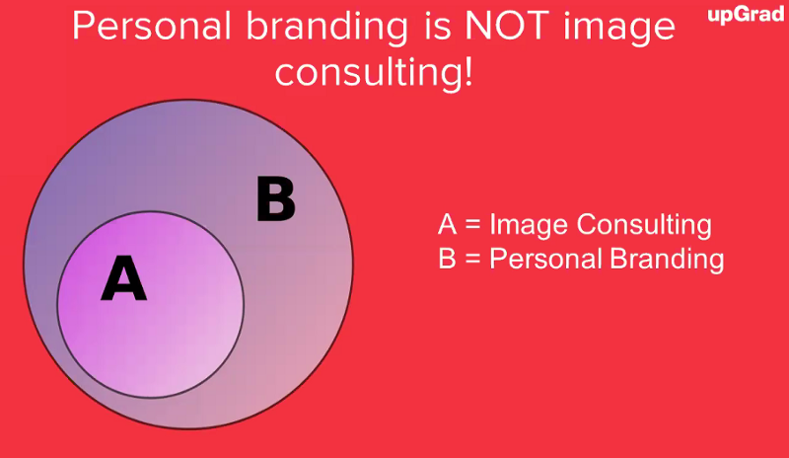

The personal brand models

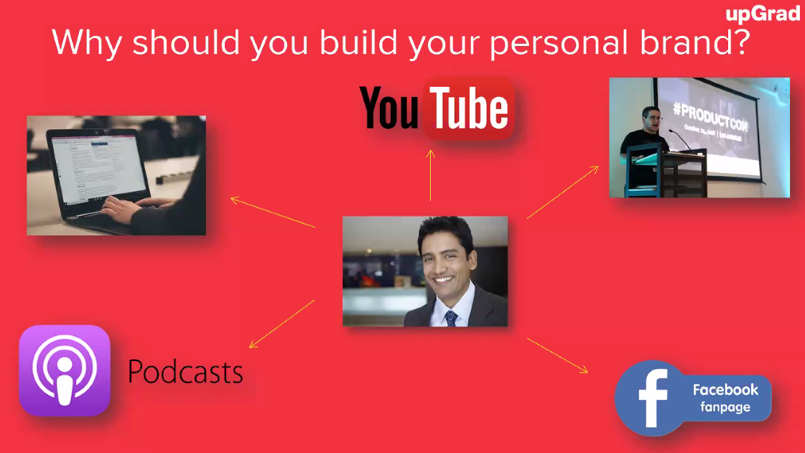

Modes of personal branding:

1. Publishing Blogs
2. YouTube
3. Conferences
4. Podcasts
5. Facebook Live

People do business with people they know, like and trust.

How do you create your personal brand?   
Personal Discovery Assessment – 360 Degrees

https://www.16personalities.com/free-personality-test

A + B + C + D

1. Appearance
2. Body Language
3. Communication (Master Active Listening)
4. Digital Footprint

Do you have a domain name? Get a domain name!

Use Wix to create a website



Blogging established authority.

Email: firstname@firstname_lastname.com

Email Signature – Get an email signature  
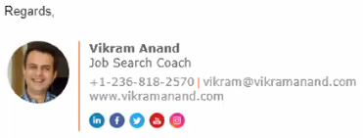

https://www.wisestamp.com/  
Website to help with Signature

Email Marketing – MailChimp, EmailOctopus (Start Email Marketing)

Messenger Marketing (Facebook – create a chatbot)  
https://manychat.com/

Host a Webinar (Intermediate)

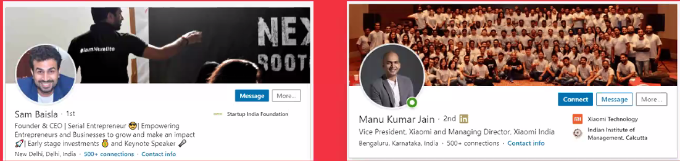

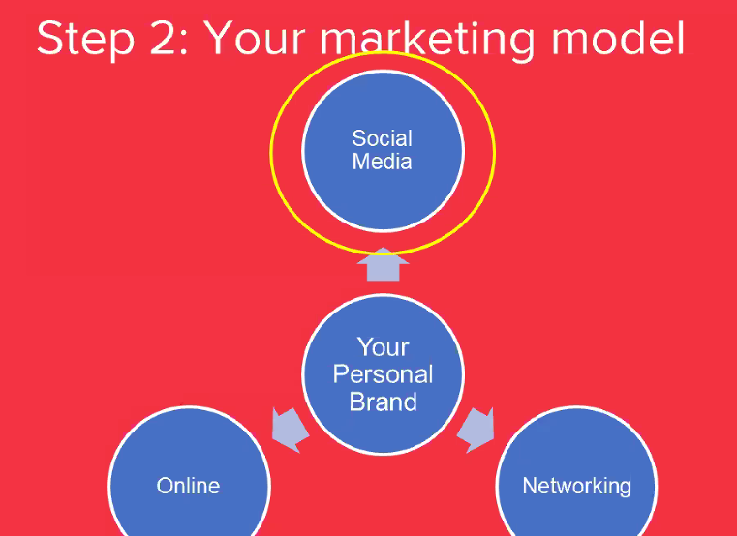

Build a Faebook Page

Facebook Live, LinkedIn Love, Youtube Live

Attend or host a meetup  
https://www.meetup.com/

